**Virtual Machine Creation**

**Azure**

* Goal: To Create Azure Virtual Machine with Ubuntu Linux (Free tier)
* Summary:
  + To Select Number of virtual cpus and RAM (in GB) we select VM Size
  + OS in the VM is choosen by VM Image which gets copied into virtual disk which is referred as managed disk
  + The network to the vm is connected via nic which connects vm to subnet (part of vnet)

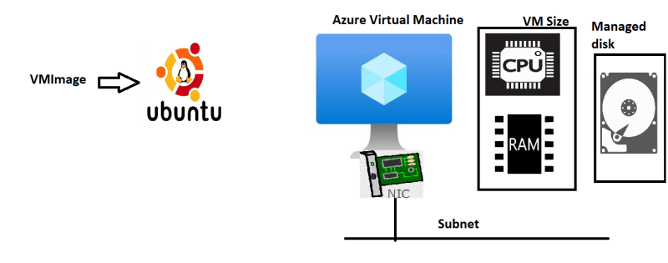

* In Azure B1s is free for 750 hours of linux usage
* Creation steps: <https://learn.microsoft.com/en-us/azure/virtual-machines/linux/quick-create-portal?tabs=ubuntu>
* Linux machine has two ways of login
  + username and password
  + username and key (private key with us and public key with linux)
* To login into vm the ssh command

ssh -i <path to pem file> <username>@<ipaddress>

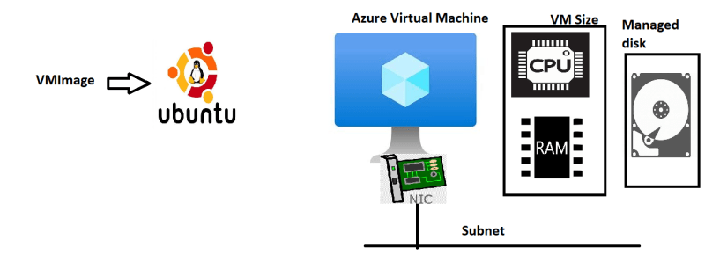

**AWS**

* In AWS the service to create vms is called as EC2
* The OS is chosen by AMI (Amazon Machine Image)
* number of vCPUs and RAM size is chosen by instance size
* The size which is free for 750 hours is t2.micro (t3.micro)
* SSH Private Key and public key is managed by AWS EC2 key pairs
* Follow the steps below to create an ec2 instance  
  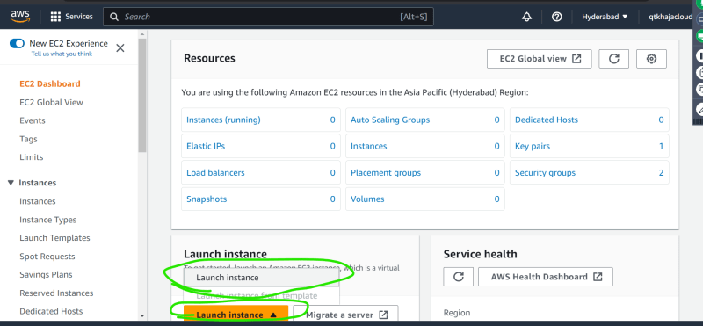  
  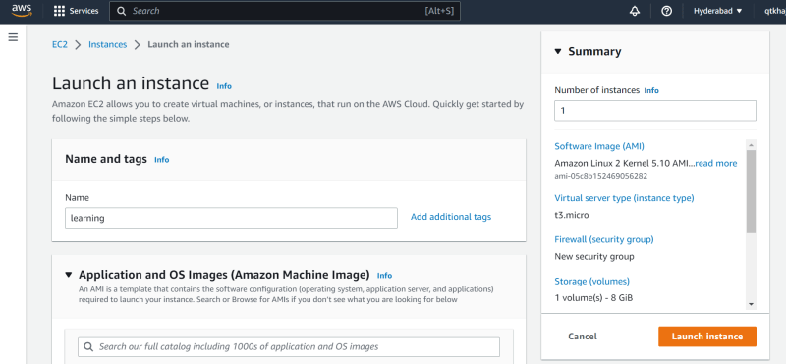  
  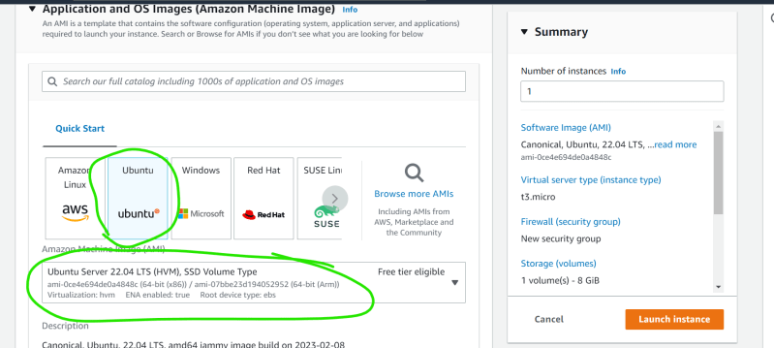  
  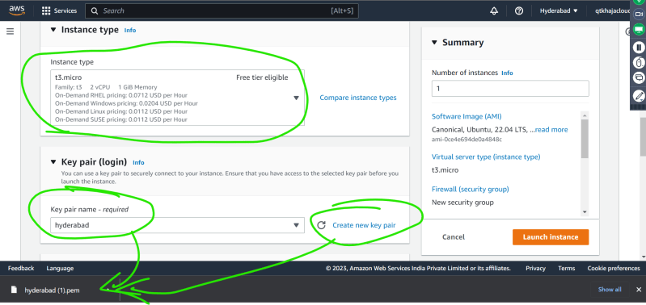  
  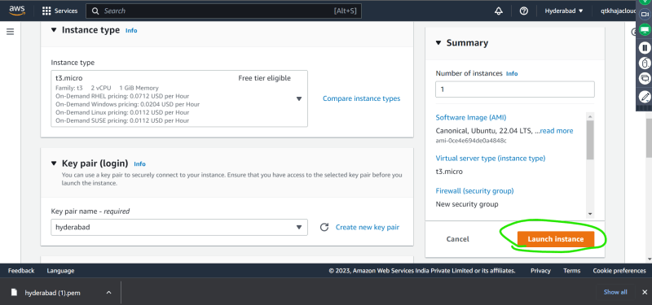  
  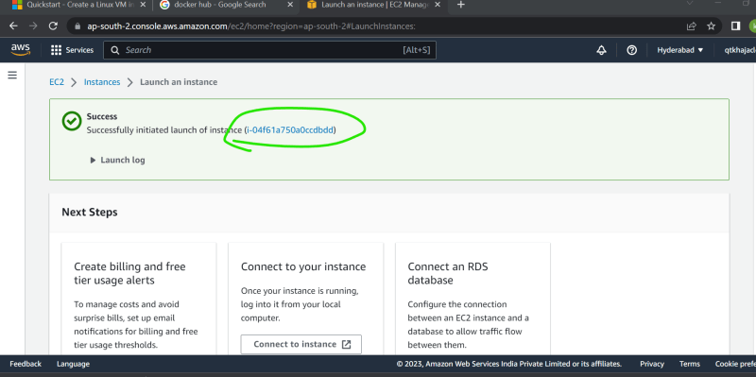  
  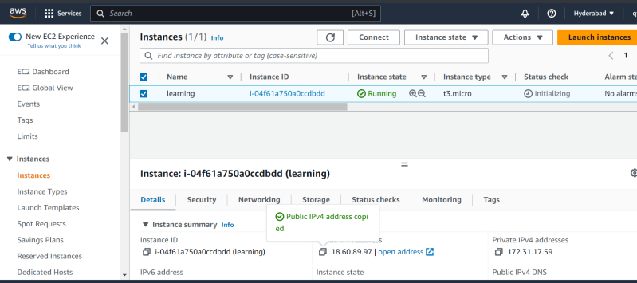
* Now lets connect using ssh

ssh -i <path to pem file> username@ipaddress

